[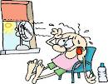](http://www.google.com/imgres?imgurl=http://www.filtersfast.com/blog/wp-content/uploads/2011/07/heat-wave.png&imgrefurl=http://www.filtersfast.com/blog/index.php/tag/heat-wave/&usg=__fs4_FyCHmTA_Q9acGqkPosRYkHk=&h=390&w=500&sz=78&hl=en&start=15&zoom=1&tbnid=VMfxCab2TuBM2M:&tbnh=101&tbnw=130&ei=dyUpUODlCKr40gHG6YGwBQ&prev=/search?q=heat&hl=en&gbv=2&tbm=isch&itbs=1) **Semper Safe** 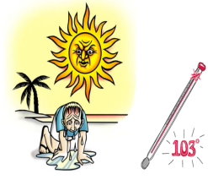

## “Heat Stress”

As we approach the last part of the summer season, severe heat becomes an issue in the Camp Lejeune area. Extended periods of heat can deplete your body of water making you more susceptible to problems such as heat stress. Long exposure to this kind of weather can result in heat cramps or heat exhaustion, and if heat stress continues, a person may suffer a heat stroke, which can be fatal. Hot humid weather depletes moisture from the body quickly creating a dangerous condition that can interfere with the body’s ability to cool itself. You must take precautions to avoid heat stress and you must also know the symptoms and emergency procedures of heat stress so that you may assist a co-worker or a loved-one who is suffering from a heat-related illness. Familiarize yourself with the symptoms and prevention methods below in order to protect yourself from heat cramps, heat exhaustion, and heat stroke during hot, humid conditions.

**Heat Cramps** Painful cramps of muscles usually in the stomach, legs, and/or arms and excessive sweating. They are caused from being dehydrated. They may occur without the individual feeling thirsty.

**Heat Exhaustion** Symptoms include profuse sweating, headache, weakness, paleness, nausea, vomiting, shortness of breath, and dizziness. If ice is available put them on the individual’s wrist, armpits, groin and neck to cool large veins.

**Heat Stroke** This is a medical emergency that may result in death. It is typically defined as a core temperature greater than 105˚F or any change in mental status of an affected individual with any elevated core temperature. If ice is available use it the same way you would for Heat Exhaustion.

**Preventing Heat Stress**

* Know signs/symptoms of heat-related illnesses; monitor yourself and others around you.
* Block the direct sunlight. Consider using a sunscreen of SPF 15 or higher (the most effective products say “broad spectrum” or “UVA/UVB protection” on labels.)
* Use cooling fans/air-conditioners; rest regularly.
* Hydrate, Hydrate, Hydrate!!! If you are working or playing outside drink about 5 to 7 ounces of water every 15 to 20 minutes.
* When you are able, wear lightweight, light-colored, loose-fitting clothes.
* **Avoid Alcohol**, caffeinated drinks, or heavy meals.

***As Marines, Sailors and Civil Servants we live by our core values. So think before you jeopardize the safety of yourself, your fellow Marines, Sailors, civilian employees or***

***family members, and remember SEMPER SAFE!***   
 SS 12-08

[](http://www.google.com/imgres?imgurl=http://www.filtersfast.com/blog/wp-content/uploads/2011/07/heat-wave.png&imgrefurl=http://www.filtersfast.com/blog/index.php/tag/heat-wave/&usg=__fs4_FyCHmTA_Q9acGqkPosRYkHk=&h=390&w=500&sz=78&hl=en&start=15&zoom=1&tbnid=VMfxCab2TuBM2M:&tbnh=101&tbnw=130&ei=dyUpUODlCKr40gHG6YGwBQ&prev=/search?q=heat&hl=en&gbv=2&tbm=isch&itbs=1) **Semper Safe** 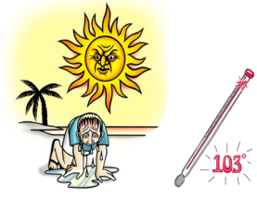



SS 12-08